BlinkIT Grocery Data Analysis
Statement: KPI
1.TOTAL SALES 3.Total Items
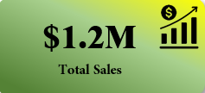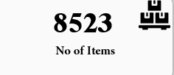
2.Avg Sales 4. Rating
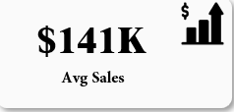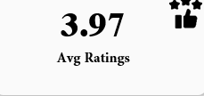

- Total Sales by Fat Content
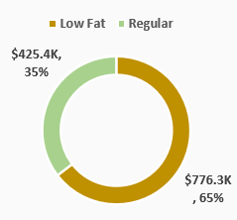

From above Donut chart we analysis that Total sales of fat content . The Total sale of low fat is more than regular

- Total Sales by Item Type
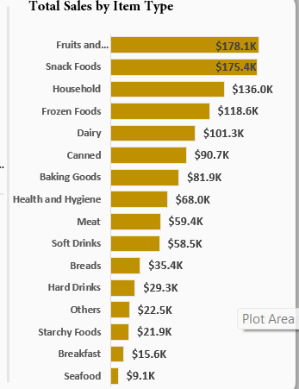
From above bar Graph Fruits and vegetable,snack foods and Household generating the hight sales and Breakfast and seafood is generating the low sales

- Fat by Outlet
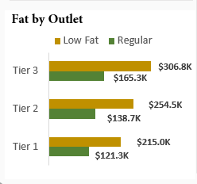
from the above chart we compare the total sale across different outlets segment by fat content Tier-3 is generating the more sales

- Total Sales by outlet Establishment
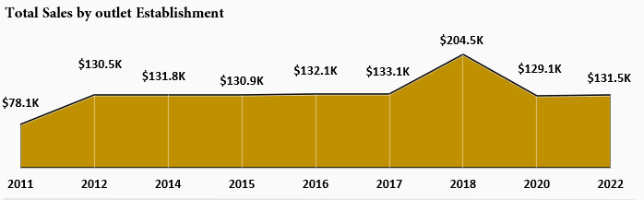
From above Area graph we analysis that in the year 2018 generated the highest sales as comparing to the another year

- Sales by Outlet size
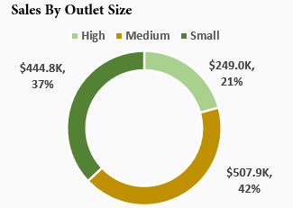
From the donut chart we analysis that the Medium outlet size is generating the more revenue as comparing to High and small

- Sales by outlet location
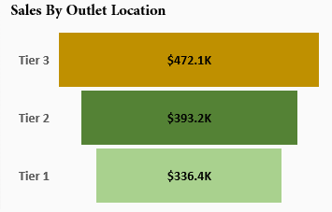
From above funnel chart we analysis that Tier 3 is generating the more revenue as compare to Tier 2 and 3

- Outlet types
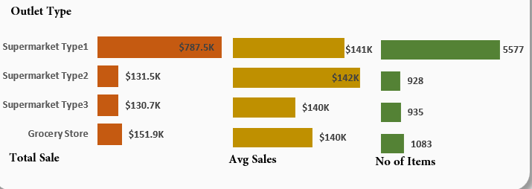

From the above bar chart we analysis that the Total sales , Average sale and no of item from the types of stores the maximum sales and order are getting from the supermarket type 1

